
phgy312
lecture #: | date: | professor:
28  29 | March 16, 2007  March 19, 2007 | Dr. Mortola  Dr. Mortola
30  31 | March 21, 2007  March 23, 2007 | Dr. Mortola  Dr. Mortola
announcements:
- I will be putting up the rest of the ntcs online as I get them, so stayed tuned to the message boards and Athena for updates!

Edited by: Aradhana Persad and Tiffany Chan
set #10
PHGY 312 – Lecture 28 March 16, 2007
Writer: Aradhana Persad Dr. Mortola

RESPIRATORY PHYSIOLOGY - PULMONARY PRESSURES

I. REVIEW OF LAST LECTURE:
- Diaphragm and intercostals and their actions on the chest wall
  - The chest wall is defined physiologically, not anatomically, as a functional term. It is anything that moves outside the lungs as a result of breathing
- Mechanisms of air convection (in vertebrates)
- Intrinsic mechanical properties of the muscles
  - Force-length relationship
  - Force-velocity relationship
- Maximal inspiratory and expiratory efforts

II. REVIEW QUESTIONS FROM LAST LECTURE
Correct answers are bolded.

1. The pressure developed by a muscle:
- Increases as its length decreases
- Wrong. As the length increases, the force (and therefore pressure) increases, since force is proportional to pressure.
- Increases as the velocity of shortening increases
  - Wrong. As the velocity of shortening increases, the force decreases.
  - Recall, when the muscle is shortening with zero velocity, this means that it is not shortening and it is called an isometric contraction. Therefore, since the muscle is not shortening, it is generating the greatest force.
- Is inversely related to the area where its force was applied
- Recall that the pressure is simply force per unit area. Therefore, if we decrease the area, we increase the pressure for a given amount of force.
Pressure = Force / Area

2. Local respiration is typically found in fish and amphibians. In addition to mammals, the diaphragm is typically found in:
- Fish
- Amphibians
- Birds
- Reptiles
- None of the above
  - The diaphragm is characteristic of only mammals, just like hair and mammary glands are. Therefore, in the respiratory system, the diaphragm is unique to mammals and none of the above answers are correct.

Note: The following question is a Type C Multiple Choice question. All Dr. Mortola wanted us to do in class is determine whether or not the first and second parts of the following sentence are true or false. Dr. Mortola will not ask us questions like this on the exam!

3. The maximum expiratory effort is at TLC because at TLC the expiratory muscle can contract very fast.
  - To answer this question, recall that we talked about the maximum expiratory and inspiratory efforts at TLC. Here, we are talking about the contraction of the expiratory muscles since we are dealing with expiration.
  - The first part of this statement is true: The maximum expiratory effort is at TLC.
  - This is because at TLC the expiratory muscles are stretched, and thus they are at their longest length. Since length is proportional to force, when stretched maximally, they can generate the largest force.
- The second part of this statement is false: It DOES NOT occur at TLC because the muscles can contract quickly.
  - This is incorrect because we are talking about STATIC pressure, the amount of pressure that can be generated statically. In this cause, it is the amount of pressure at the static volume TLC. Therefore we are not talking about speed in this situation and the velocity of contraction does not affect the maximum expiratory effort at TLC.

4. The maximum inspiratory work of breathing is about twice the expiratory work.
  - Work is the area of a pressure-volume graph. Therefore, in 3D structures, work is defined as pressure times volume:
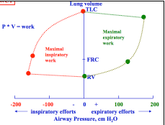
Work = Pressure x Volume
- Where pressure is force/area and volume is area x length.
  - Cancel out the units and you get work in terms of force x length.
- Therefore the area within the right half of the graph represents the maximum work available to the expiratory muscles and the left half of the graph represents the maximum work available to the inspiratory muscles.
- As we can see, the maximum inspiratory work available is NOT twice as large as the maximum expiratory work available; it may actually be smaller. Thus, the statement above is false.

5. The countercurrent gas exchange:
- Occurs in animals or subjects with large physiological dead space.
- This statement is wrong. Countercurrent gas exchange only occurs in subjects with NO dead space, such as birds and fish.
- Mixed arterial P_{O2} approaches the value of the inspired gas
- Is not efficient for the elimination of CO₂
- This is incorrect. Anytime that O₂ is being exchanged, CO₂ is being exchanged as well. In fact, CO₂ is actually more soluble than O₂ and is therefore exchanged even better. Thus it is easier to eliminate CO₂ from the body than it is to absorb O₂.

III. ELASTIC AND RESISTIVE PROPERTIES
- Last time we talked about the force-length relationship, the velocity of shortening, the geometry and the action of the muscles. In the end, the generated pressure must be translated into volume and flow.
- Your muscles contract and generate a pressure (force per unit area), but this is not quite enough. Air flowing in is dependent upon the mechanical characteristics of the respiratory system.
- For us, these are the elastic properties and the resistive properties of the system.
- For example, the diaphragm is capable of generating as much pressure as we want, but if we are inspiring against a large resistance (ie. due to an occlusion in the airways) air will not enter.
- Therefore the translation of pressure into ventilation depends on the resistance of the system.
- What happens if you are extremely stiff (ie. high elastance)? Once again, no matter how much pressure you can produce with the functional muscle, you are still not able to get air in.

Take Home Message: The elastic properties and the resistive properties of the muscles tell you how much pressure will be translated into volume, and eventually ventilation.

IV. TERMINOLOGY
- Before we continue, we must first agree on terminology.

Barometric Pressure
- In Montreal, the barometric pressure is 760mmHg, but in Denver, Colorado it is closer to 600mmHg and at the top of Mount Everest it would be half this value. As we can see, this can become very confusing.
- Therefore, from now on we will consider barometric pressure to be 0mmHg.
- So this means that whenever we refer to something as being subatmospheric, we mean that is below zero.

Passive and Active
- Passive means that there is no activity in the respiratory muscles.
- Active is defined as working respiratory muscles. In other words, it means that the muscles are contracting.

Static and Dynamic
- Static is defined as no airflow.
- Dynamic means that there is the presence of airflow.

- We can have all of the above four mixed together and working as different combinations.
  - For example, if you are breathing in during inspiration you must be active and dynamic.
  - But when you are relaxed at the end of inspiration (at FRC), you are passive and static.
  - If you are holding your breath, you are static but active because you are contracting your muscles.
  - What happens when you breathe in, close the larynx and relax? Your larynx is blocking airflow, therefore you are static and you have relaxed your muscles so you are also passive.

The Balloon Analogy:
- We often use a balloon as an example of the respiratory system.
- Whenever we say that the balloon is under transmural pressure we are always referring to the pressure differences between the inside and the outside of the balloon. It is never the opposite!
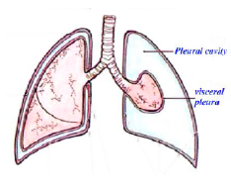
Transmural Pressure = inner pressure – outer pressure
- Therefore, when a balloon is under positive transmural pressure, the balloon is inflated because there is a greater pressure on the inside than on the outside.
  - For example, if you blow into a balloon and then hold it. The balloon is not deflating because you are applying infinite resistance to it. However, the balloon is inflated because it has a greater inner pressure than outer pressure.
  - Since the pressure inside exceeds the outer atmospheric pressure (taken to be zero), when you release the balloon, it will deflate.

- If you make a hole through the thorax, in the space between the lung and the ribcage, the lung will deflate. Why? Normally, the lung is at a positive transmural pressure and would like to deflate, but it cannot because the chest is opposing it.
- Thus the chest tends to move out and the lungs tend to move in. Between these two structures is pleural fluid. The pressure in the pleural fluid tends to be a little negative.

Note: Piercing a hole into the thorax results in pneumothorax, which is defined as the collapse of the lung (or a portion of it), due to a gas (usually air) in the pleural space.

V. FUNCTIONAL RESIDUAL CAPACITY (FRC)
- If you were suddenly able to remove the lungs, what would happen to the chest wall? The chest wall would expand. At FRC, the chest tends to expand and the lung tends to collapse, thus these two opposing forces are at equilibrium. This is a crucial property of the lung.
  - It is energetically expensive to try to re-inflate the lung from a collapsed state.
- This is similar to when you initially try to inflate a balloon. In the beginning, it takes a lot of effort to expand the balloon. Once the balloon has already expanded, it becomes easier to inflate.
  - A deflated, folded lung is much harder to inflate than a balloon because the lung sticks together, due to surface tension.

- Consider the following example:
- If you are trying to inflate a lung through the trachea, from the deflated state, you see that it will do so gradually.
- This must be done slowly because if you try to inflate the lung too quickly, the rapid influx of air will break the lungs.
- In this case, from deflation, the lung will fill up unevenly and you will see an uneven distribution of expanded alveoli. This is not what we want happening in our bodies. Instead, we want our lungs to inflate evenly and we do not want it to deflate completely with each breath.
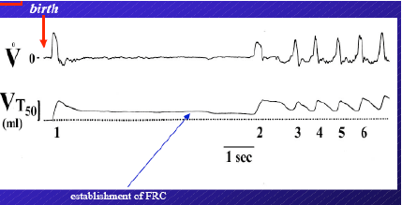
- During thoracic surgery, a ventilator or a person pumps air into and out of the lungs to prevent it from collapsing.
- With a baby’s first breath, the amount of air inhaled exceeds the amount of air exhaled. This continues over the next few breaths and allows for the establishment of the FRC.
    - This emphasizes that it is crucial to have an FRC as early as birth.

- In addition to maintaining an inflated lung, FRC also acts as a P_{O2} buffer during expiration. When we expire, we are still consuming O₂ but we are no longer bringing fresh O₂ into our body. Thus the P_{O2} in our blood will begin to drop, but how much it drops by is determined by our reserve (ie. our FRC). Therefore, if we did not have FRC we would have huge oscillations in our alveolar and blood gases with each breath.
    - For example, this property of FRC results in the P_{CO2} of 40mmHg seen in our bodies.
- FRC also allows for a reserve of O₂ in our bodies, so if we miss a breath or have to stop breathing for whatever reason (accidental or voluntary), we will still have about 2L of fresh air in our lungs, containing about 20% O₂.

- As we can see FRC is extremely crucial. As a result, all animals have an FRC, which is proportional to their body size. Therefore, FRC is also considered to be an interspecies constant.

Interspecies Constants
- We now have three interspecies constants:
    - Tidal volume (per kg)
    - Dead space (per kg)
    - FRC (per kg)

Recall: To compare interspecies values, you must normalize them. Dividing these values by their mass to obtain values in per kg does this.

- The respiratory system consists of many parameters. Some are more important from an engineering point of view, while others are more flexible. Note that flexibility is usually with respect to a time component.
- However, the most crucial parameters are usually those related to volume.

VI. PULMONARY PRESSURES
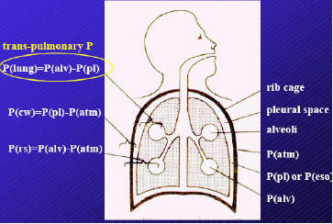
- To find out how much force and pressure is needed to expand the lungs, we must measure the transpulmonary pressure across the lungs.
- To determine how stiff the chest wall is we would need to measure the pressure against the chest wall.

Terminology:
- Cavity between the rib cage and the lungs is the pleural space, which is filled with pleural fluid. The pressure in the pleural space is denoted P_{pl} or P_{eso} (esophageal).
- Recall, we defined the atmospheric pressure (P_{atm}) as 0 mmHg.
- The alveolar pressure is the pressure in the alveoli (P_{alv})

- If the subject is in static conditions, the pressure measured in the alveoli must be equal to the pressure at the mouth because there is no flow. Thus, it is very easy to measure alveolar pressure during static conditions. This can be done using a manometer.

- This means that if we want to measure the transpulmonary pressure, the pressure across the lungs, all we need to know is the pleural pressure.

Transpulmonary Pressure: P_{lung} = P_{alv} – P_{pl}
- Intuitively, it may seem difficult to measure the pleural pressure, however it has been discovered that pleural pressure is equal to the esophageal pressure (P_{eso}), because both the esophagus and the pleural space are in the thorax.
P_{pl} = P_{eso}
- Thus, fluctuations in the pleural pressure corresponds to the pressure at a certain location in the esophagus and this can be measured by placing a catheter, connected to a pressure transducer, up the nostrils and down into the esophagus.
- Recall that we can measure the volume of the lungs using a spirometer. Therefore, we know both the volume and the pressure of the lungs. These are the two measurements needed to measure compliance.
Compliance = ∆V / ∆P_{static}

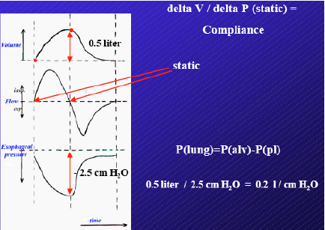
- The figure to the right illustrates the changes in volume, flow and esophageal pressure.
- Note that in the time-flow graph, the beginning and the end of respiration are static, while everything else is dynamic.

- Therefore, to obtain compliance, we can simply measure the change in volume and divide it by the change in esophageal pressure at these two static locations.

- For example, if the subject is breathing 0.5L and the pressure he needed to breathe in the 0.5L of air was 2.5 cm H₂0, then the compliance would be:

Compliance = 0.5 L / 2.5 cm H₂0 = 0.2 L/cm H₂0

Note: This value is actually very close to the actual value that most of us would have.

- Compliance is generally a constant value. This means if we increase our volume to 1L, then the change in static pressure would also double. In other words, the volume and pressure will change proportionally to each other.
- However, compliance is not completely constant. Compliance changes a little with volume. So if the subject begins to breathe very deeply, he will need to use extra energy to do so.

Note: Dr. Mortola has used compliance and elastance interchangeably throughout this lecture. Recall that we covered the difference between these two terms in our cardiovascular section. Elastance is the reciprocal of compliance. Elastance = 1/compliance. Compliance is the change in volume/the change in pressure. Elastance, on the other hand, is the change in pressure/the change in volume.

- This means that the slope of the line in a Pressure (x-axis) – Volume (y-axis) graph is the compliance. As the lung volume increases, the compliance decreases. This measurement is very important because it tells us a lot about the characteristics of the lung.
- For example, some may talk about the recoil pressure of the lungs, but in reality the recoil pressure is the same as the compliance of the lungs.
- The recoil pressure increases when the compliance decreases and vice versa.

Fibrosis and Emphysema
- There are many situations when the compliance behaves abnormally.
- There are two main, opposing pathologies associated with compliance.
- Fibrosis is when the lung becomes stiffer (decreased compliance).
- Chronic lung disease occurs when the compliance of the lung increases. This includes emphysema, which is usually seen in smokers.
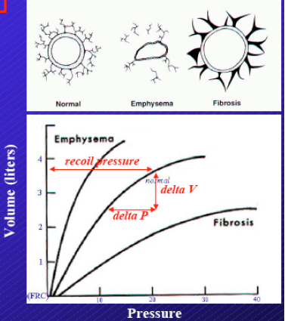
- In fibrotic patients, this means that they must work harder to breathe.
- Emphysema patients have a lower volume related pressure, and thus it is easier for them to breathe in.
- It may seem better to have higher compliance, and while in some cases it is beneficial, it is not in the extreme case of emphysema. We will be looking at the prices you have to pay when your compliance is too high later on.

- It is generally easier to diagnose fibrotic patients. This is usually done using a simple vital capacity test.

- For the same volume, fibrotic patients need more pressure, to the point that they will never be able to reach the TLC of a normal person.
- A fibrotic patient will have a very stiff rib cage, but has no problem expanding the stomach, because this is a property of the diaphragm, which is still functioning normally. The patient will also have no problems increasing his frequency of breathing because his resistance is also still normal.
- However, when this person breathes, his rib cage hardly moves because of the increased stiffness of his lungs.
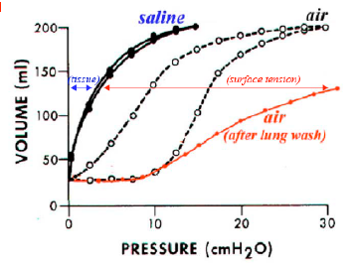
Surface Tension Within the Lungs
- It is reasonable to assume that the tissue of the lung is what governs its compliance, in the same way that the wall of a balloon governs its elastic properties. However, the tissue of the lung is actually a minor component of the pressure needed to inflate it. The major component is due to the surface forces, the tension of the air-liquid interface inside the lung.
- Although the lung is filled with air, it is also very wet. The contact between these two media (water and air) generates a surface tension. In turn, this surface tension generates a pressure.

- If you inflate a lung from rest, you see that it takes more pressure to inflate the lung than it takes to deflate the lung. This is called hysteresis, meaning that you do not follow the same pressure-volume relationship when you are inflating and deflating. (Black broken-line curves in the middle of the graph)
- What happens when we inflate and deflate the lungs with a saline solution?
- The compliance has increased. It takes much less pressure to inflate the lungs to the same volume.
- When we try to re-inflate the lungs with air, after washing with the saline solution, there is now a very low compliance.

How do we explain these changes?
- At any given volume, the recoil of the lung is partially due to the tissue itself. However, we can see that this is only a minor component
- The major component of the recoil is the surface tension. This surface tension can be summarized by the Young-LaPlace Relationship:
P = 2T/r

- This relationship states that when you have two media in contact with each other, in our case air and water, you create a surface tension. This tension generates a pressure, which is dependent upon the radius of curvature of the interface between the two media.
- This implies that if the radius is very small, the tension will be enormous. In other words, the pressure is inversely related the radius of curvature.
    - So if the lung is collapsed, the radius of the alveoli is very small because they are deflated. Thus, the tension is very large and the pressure needed to expand the lungs is enormous. In this case, you usually break your lungs before you are able to expand them.
- This is why very premature babies usually die. Even if they are on a ventilator, the ventilator needs to pump such high pressures that the lung usually breaks before the ventilator is able to expand it homogenously.
    - On the other hand, if the lungs are inflated, the alveoli are also inflated. Therefore, the radius of curvature is greater and there is less tension.

- In our lungs, we have a substance called surfactant, which is responsible for decreasing the surface tension.
    - Surfactant decreases tension (T) for any given volume.
- This is another problem with premature babies. They are usually born with very little or no surfactant. As before, this means that they need to generate a large amount of pressure to inflate their lungs with a very small volume of air.

- After washing the lungs, we have removed the liquid-air interface because the lungs are now filled with liquid. As a result, a decrease in compliance is seen in the curve.

Take Home Message: In an air-filled lung, we can appreciate the recoil due to the surface tension. In the liquid-filled lung we can appreciate the actual recoil due to the tissue, since there is no longer a liquid-air interface.

Surfactant and the Young-LaPlace Relationship
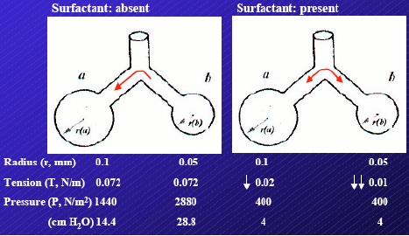
- Recall that we have about 300 million alveoli in our lungs.

Consider the following example: (See diagram)

- As we can see, alveolus A is larger than alveolus B.

- With no surfactant, the surface tension depends on the air-liquid interface and therefore it will be the same in both alveoli. In this example, the air-liquid interface generates about 0.072 N/m.
- The pressure generated is related to the surface tension and the radius. (P = 2T/r). Therefore, the pressure created in the smaller alveolus (B) will be greater.
- This variance in pressure, depending on alveolar radius, is what happens in premature babies and those without surfactant.
- The consequence of this situation is that alveolus B will deflate into alveolus A because it has a higher pressure. On a large scale, if we have 300 million alveoli doing this, our lungs would collapse.

- Fortunately, this does not happen because we have surfactant.
- Surfactant decreases the surface tension. However, the degree to which it does this depends on the size of the surface interface. The smaller the surface interface, the greater the decrease in tension. Therefore, the smaller alveolus (B) will have a greater decrease in surface tension in comparison to alveolus A.
    - How does surfactant do this? Surfactant is lipoprotein and in the smaller alveoli, it has a larger concentration. The greater the amount of surfactant present, the greater the reduction in tension.
- In the end, this results in the homogenous distribution of pressure throughout the lungs. Therefore, the smaller alveoli can co-exist with the larger alveoli without deflating into each other.

VII. PULMONARY PRESSURES
- In addition to measuring transpulmonary pressure, we can also measure trans-respiratory system pressure (P_{rs}) and trans-chest wall pressure (P_{cw})
P_{rs} = P_{alv} - P_{atm}
P_{cw} = P_{pl} - P_{atm}

- However, P_{atm} is taken to be zero, so both of these equations can be reduced and since we know how to measure P_{alv} and P_{pl}, it is possible to obtain these transpulmonary values.
- Recall, transmural pressures are always the inside minus the outside. As we can see above, this rule holds for the above equations.

- The lung and the chest move together, therefore the volume is the same in these two structures.

Note: Dr. Mortola is introducing the following concept today and he will return to it in the next lecture.

- The y-axis represents the vital capacity, as a relative percentage.
- The x-axis is the pressure difference across the system of interest. This can be transpulmonary, trans-respiratory system, or trans-chest wall.
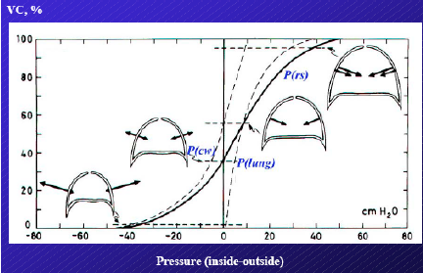
- At FRC there is no pressure across the respiratory system because the respiratory system as a whole is passive at rest.
- At FRC, the lung tends to pull inwards and thus has a positive pressure (dotted line in the positive quadrant). No matter where you look at the curve of the P_{lung}, it always tends to collapse.
- On the other hand, at FRC the chest wall is pulling outwards and therefore has a negative pressure (dotted line in the negative quadrant). These two opposing forces are in equilibrium and therefore the respiratory system is at rest.

- The thick solid line in the center is the combination of the pulmonary and chest wall pressures, which is the trans-respiratory system pressure. P_{rs} = P_{lung} + P_{cw}

PHGY 312 – Lecture 29 March 19, 2007
Writer: Roni Wisehart Dr. Mortola

RESPIRATORY PHYSIOLOGY – RESPIRATORY DEPENDENCE

I. REVIEW OF LAST LECTURE
- Measurement of absolute lung volume
  - Dilution technique
  - Spirometry
- Pressure-Volume curve of the lung
  - Depends on the tissue and the surface forces

Compliance
- Compliance is a change in lung volume over a change in transpulmonary pressure. It can be considered as the stretchiness (the opposite of stiffness) of the lungs
  - C =ΔV/ΔP
- The greater the lung compliance, the easier it is to expand the lungs for any given change in transpulmonary pressure
- Compliance is a static measurement; it is measured when there is no flow in the lungs (ie. at the beginning and end of inspiration)
  - Since it is measured when there is no flow, compliance is independent of resistance to airflow. It is simply a measurement of the pressure related to the volume.
- Changes in compliance affect the elastic properties of the lung and can lead to:
  - Fibrosis: This is due to low compliance.
  - Chronic Obstructive Pulmonary Disease (COPD)
    - Emphysema is the largest subcategory. It is due to high compliance. As we age, we all develop some form of emphysema, however severe cases are seen largely in chronic smokers.
- Elastance is the inverse of compliance
  - E = 1/C = ΔP/ΔV

Something to remember:
- Lung recoil pressure is NOT the equivalent of compliance.
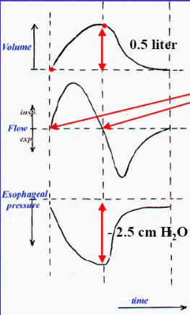
  - Recoil pressure is just pressure, or the distance of the line on the P-V curve
  - Compliance is the slope of the line on the P-V curve
  - Compliance and recoil pressure are inversely related. When compliance is low, recoil pressure is large and vice versa

Example: What do we need to measure compliance?

- We did a similar example in the last lecture. We’re just using different numbers today. Recall the graph to the right. We have volume, flow and esophageal pressure, all with respect to time. Esophageal pressure is equivalent to the pleural pressure.

- To measure compliance, we need transpulmonary pressure and volume (C = ∆V/∆P)

- Recall:
Transpulmonary pressure = Inside (alveolar) pressure – Outside (pleural) pressure

- In this example, at the end of expiration, we have a transpulmonary pressure of 5 cm H₂0.
  - At the end of expiration, we are FRC, the airway is open, but there is no flow (ie. static). The pressure must therefore be equal everywhere. Otherwise, the differences in pressure would result in flow.
    - Since the atmospheric (outside) pressure is taken to be zero, the alveolar (inside) pressure must also be zero.
  - In addition, we know that at FRC, the pleural space has a negative pressure, -5 cm H₂0 in this example.
- Therefore, Transpulmonary Pressure = 0 – (-5) = 5 cm H₂0

- What does this mean? It means that lungs are a little stressed and at FRC they would like to collapse.

What happens at the end of inspiration, after the subject has taken in about 0.5L of air?
- At the end of inspiration, the pleural pressure will be even more negative because the lungs are being stressed even further and they still want to collapse.
  - In this example, the pleural pressure has increased to -10 cm H₂0.
- Once again, we are in static conditions (no flow). Therefore, the alveolar pressure will be equal to the atmospheric pressure.
P_{alv} = P_{atm} = 0

- Therefore, we know have a larger transpulmonary pressure.
Transpulmonary pressure = 0 – (-10) = 10 cm H₂0

- From the end of expiration to the end of inspiration, our change in pressure is:
∆P = 10 – 5 = 5 cm H₂0

- In addition, from the end of expiration to the end of inspiration, our change in volume is:
∆V = 0.5 – 0 = 0.5L

Note: At FRC, we took our lung volume to be zero, and at the end of inspiration, the relative change was 0.5 L

- Now that we have the change in pressure and volume, we can now calculate the compliance.
Compliance = ΔV/ΔP = 0.5 L / 5 cm H₂0 = 0.1 L/cm H₂O

II. REVIEW QUESTIONS FROM LAST LECTURE:

Which of the following are effects of decreased surfactant?
a) Lung emptying favored
b) Lowers FRC
c) Increases recoil pressure of the lung
d) Improves alveolar stability

Answer: a), b) and c)
- Correct: Surfactant lowers surface tension, which increases lung compliance and makes it easier to expand the lung. Therefore, without surfactant lung contraction is favoured and thus, lung emptying is favoured.
- Correct: As explained above, with low surfactant you have stiffer lungs. This means the chest will resist the recoil pressure less and FRC goes down (ie. more air is forcefully expired).
- Correct: Without surfactant, pressure favoring expiration (recoil pressure) is increased.
- Incorrect: Surfactant DOES NOT increase alveolar stability. It decreases alveolar stability. Recall the example in the previous lecture with the small and large alveoli, with and without surfactant.

III. LUNG VOLUMES

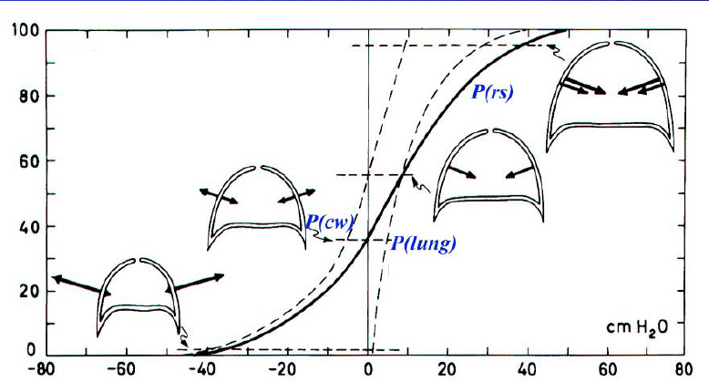
- Recall the diagram on the right showing the pressures of the lungs. The x-axis represents the differences in pressure (P_{inside} – P_{outside}) and the y-axis is the relative vital capacity as a percentage.
- Positive pressures favor lung collapse and negative pressures favor lung expansion.

- The lungs alone will always tend to collapse. This happens even when we are at FRC or RV, our lowest volumes.
- This is shown by the P_{lung} curve

- The chest wall tends to expand, thus opposing this collapsible force of the lung. At FRC, these two opposing forces are in equilibrium.
- However, as the lung volume increases, the chest pressure gradually favors lung collapse as well.
  - The chest wall (P_{cw}) crosses over at 50-60% of vital capacity to favor collapse

Take Home Message: At lower lung volumes (VC < 50-60%), the chest wall tends to expand and opposes the collapsible forces of the lungs. This helps to favour lung filling. But, as the lung volume and VC increases, the chest wall crosses over, at a VC of about 50-60%, and favours collapse as well.

- This means that at higher lung volumes, we have two forces affecting breathing; both the chest wall and lung favour recoil.
- At lower lung volumes, the system springs back out. This is due only to the chest pressure.

- So, at higher volumes, for example TLC, there are two sources affecting breathing: both chest and lungs favor recoil of the system
- At low volumes (ie. RV or FRC) the system springs back out, but due to chest pressure only

What is the limiting factor to TLC?
- Both the chest and lung because we are at a high volume
What is the limiting factor to the lowest volume you can exhale?
- Only the chest wall because at low volumes, it is contributes to lung filling not emptying. The lungs are favouring exhalation.

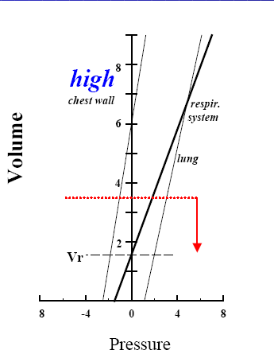
IV, COMPLIANCE AND RECOIL PRESSURE
- Compliance and recoil pressure are not the same!
  - Recoil pressure is the distance of line from zero pressure
  - Compliance is the slope of line

- If you shift the line on the graph (the chest wall or the lung line) to the left or the right, you change the recoil pressure, but the compliance stays the same because you are not changing the slope of the graph.

- There are many situations in which one can change (compliance or recoil pressure) while the other stays constant.
- For example, consider newborns. Their chest wall is very compliant, so the lung pressure is not changing but the chest wall pressure is. Thus, for the same compliance of the lung and a higher compliance (lower recoil) of the chest, FRC goes down

V. FLOW AND RESISTANCE
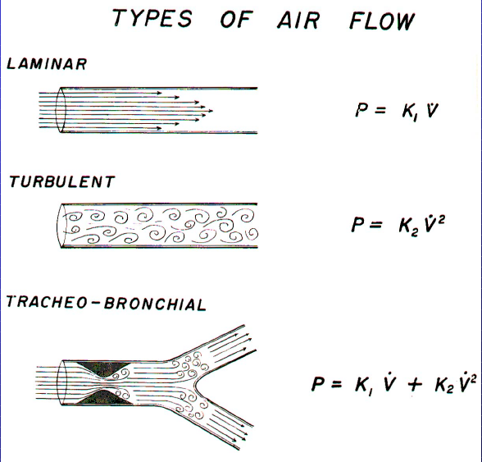
How much pressure do we need to breathe in?
- We know that pressure is related to compliance and volume and we must overcome the compliance of the system. The extent of this depends on how much air we want to enter.
- To overcome a given volume is static. If we want to do this in a given time, we must overcome a given volume and generate an even flow; this becomes a dynamic property.

- Now that we have to consider flow, we must also overcome the work of the resistive pressure. Resistance is determined by the characteristics of flow:
  - Laminar flow: pressure is proportional to the flow
P = K₁ x V
  - Turbulent flow: pressure is proportional to the square of the flow
P = K₂ x V²

Is laminar flow found in the large (trachea) or small (periphery of lung) airways?
- Laminar flow is found in the periphery of lungs.
- A large radius, such as in the trachea, leads to turbulent flow. This is because the velocity of flow is higher in the larger airways and therefore, it more likely that flow will occur.
- The surface is large in periphery meaning the velocity very small (almost zero), so the chances of having turbulent flow are much less

River Analogy:
- Consider a river. When the river is wider, the flow is fast faster and more turbulent, but when the river is narrower the flow is slower and much less turbulent
- Flow in the peripheries depends on the length and more importantly, on the radius of the airway, since both of these properties determine the resistance.
- Recall Pouiseuille’s Law, which relates pressure (P), flow (Q) and resistance (R):
∆P = Q x R

- Also recall:
R = (8ηL) / (πr⁴)

  - R = resistance
  - L = length
  - η = viscosity
  - r = radius

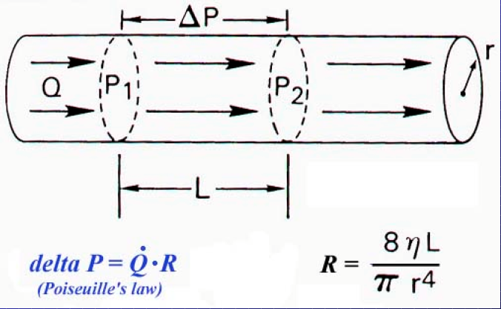
If you change the length, the effect on resistance is relatively small. This is because length is only to the 1st power and it is directly proportional to the resistance
- However, if you change the diameter, the effect on resistance is large
  - Radius is inversely proportional to resistance and it is to the 4th power (r⁴)
  - Therefore, even a tiny change in tone, which regulates diameter, will have a profound effect on resistance and therefore, the flow.
  - For example, if we decrease the radius by half, we will increase the resistance by 16x.
[(1/2)⁴ = 1/16, R and r are inversely proportional]
- As you can see, if you have a very large radius, you have a very small resistance and as a result, you will have a very high flow velocity, resulting in turbulent flow.

VI, EQUATION OF MOTION
- The equation of motion is the sum of the static and flow pressures, which equals the total pressure required to inflate the respiratory system. If you vary any of these components, you change the total pressure.
- For example, to increase the pressure you can breathe faster, increase resistance, decrease compliance, or increase volume.
P_{static} = V x (1/C)
P_{flow-resistive} = Q x R

P_{total} = P_{static} + P_{flow-resistive} = [V x (1/C)] + [Q x R]

The Work of Breathing:
Work = Pressure x Volume
- The work required to breathe is a small amount of the total energy we dissipate at rest; only 5% goes to respiration
- If you are performing at a high level of ventilation though, the work of breathing increases
  - The amount of work can get so high that all your energy goes to the respiratory muscles. This is what occurs in severe hypoxia
- This is partly why it is hard to climb at high altitudes; there is little oxygen and we must ventilate for two reasons. One, we are exercising and require more oxygen. Secondly, we are doing this under hypoxic condition.
  - The air we pump in goes to the respiratory muscles, not to the muscles of the legs etc
  - So to solve this, we try to ventilate more in order to dissipate the work of breathing

Note: Normally, breathing only uses a small fraction of the oxygen we take in and this is a somewhat extreme situation.

VII. EXPIRATION: RECOIL PRESSURE AND TIME CONSTANT
- The driving force of expiration is the recoil pressure of respiratory system
- We must pay to expand our lungs, in order to overcome the compliance and resistance of the system, but once we do so, there is energy stored in the system
  - The system has been stressed like a balloon; we must pay to inflate the balloon, but once it’s inflated there is elastic energy being stored. If you open the balloon, it will spring back down.
  - The same applies to your lungs. The energy you put in for inspiration is enough to bring the system back to FRC.
- At rest, expiration is a dynamic passive phenomenon, meaning no muscles are involved.
  - The exception to this is at the beginning of expiration, when the muscles act to break the initial rapid speed of expiration. However, this is usually minimal.

What if we want to speed up expiration?
- In other words, what if we want to decrease the amount of time it takes to breathe out?
- The time it takes to exhale depends on the time constant of the respiratory system

Time Constant = Compliance x Resistance
= (Volume/Pressure) x (Pressure/Flow)
= (L/ cm H₂O) x (cm H₂O/ L /sec)
= seconds

- The time it takes to breathe out is normally 1-2 sec

- Consider a high compliance situation (ie. emphysema) or a low compliance situation (ie. fibrosis),
- Obviously, in both of these cases, the time constant will change since it is dependent upon compliance and the compliance is changing.

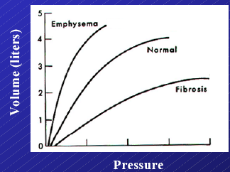
Who will breathe out more quickly?
- The fibrotic patients will expire faster because they have a lower compliance and since compliance is directly proportional to the time constant, the time constant will also decrease.
- As a result, fibrotic patients have no problems expiring because their system springs back quickly. On the other hand though, they will have a harder time inspiring due to the increased stiffness of their lungs (low compliance).

- In patients with emphysema, the high compliance helps them inspire because they don’t need a lot of pressure to do so.
- However, since they have a lower recoil pressure (higher compliance), their spring action has decreased. As a result, since they have lost their recoil pressure, needed to bring them back to FRC, it takes them longer to breathe out; their time constant has increased.
  - Using the balloon analogy, the spring is broken and this is like a floppy balloon.
- In these patients, the recoil pressure takes so long to cause expiration that the patients take another breath before the previous breath is exhaled.
  - These patients usually need to sit down because sitting decreases their compliance, thus favouring expiration, which is what they want.
- In addition, many of these patients try to flex when they want to breathe out

Why can’t some emphysema patients breathe out even when they forcibly try to?
- Picture the lung as a balloon with a pipe. When the balloon is inflated and you push on it, air comes out, but it’s not that simple.
- In reality, the pressure you put on the balloon is also acting on the pipe because the pipe is in also in the container (ie. the thorax). Equivalently, the lungs and some of bronchioles (~50%) are in the thorax.
- When squeezing balloon, this also squeezes the pipe. So the more you squeeze the balloon, the more you squeeze the pipes.
- Therefore, when an emphysema patient forces air out, it does nothing because it is collapsing the intrathoracic airways, which are too soft due to the high compliance.

- When the patients get sicker, they tend to go to high lung volumes because they gain a little bit of lung recoil. This why you see these patients with over-inflated chest.
- When they get even sicker they try to push out air and have forced expiration for each breath. However, this causes them to collapse their own airways and they eventually start retaining CO2. In the end, these individuals are trapped by their own respiratory system and eventually die.

VIII. MECHANISMS OF FORCED EXPIRATION

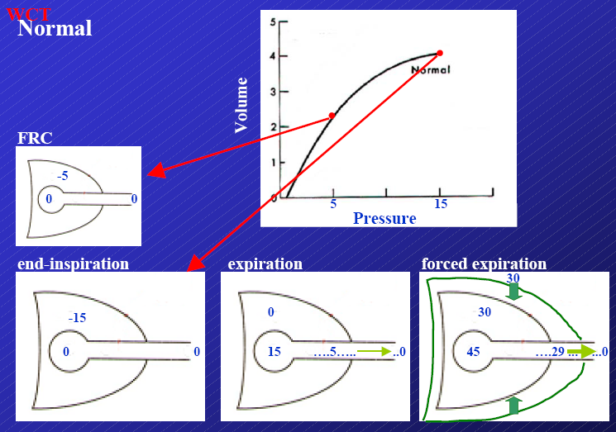
Under normal conditions:
- At FRC, we have a pleural pressure of -5 and at the end of inspiration it decreases to -15 cm H₂O.
- When you let it go, your muscles are no longer holding the chest out and the 15 cm H₂0 is transferred to alveoli. The increased pressure in the alveoli causes air to flow out.
  - How long this takes depends on the driving pressures.

What if the subject is pushing out?
(Last panel, “forced expiration”)
- Additional pressure is coming from the chest (respiratory muscles) and as a result, the pressure in the alveoli becomes 45 cm H₂O, as opposed to 15.
- This is what happens when you cough.
- Eventually, you reach a point where the pressure in airway is equal to the pressure applied by the chest. This is called the equal pressure point and at this point, the airway begins to collapse because the pressure outside (atmospheric) exceeds the pressure inside (alveoli).
- If this happens in the large airways, the cartilage present resists the collapse of your airways, but if this occurs in the periphery of the lungs, it is a problem.
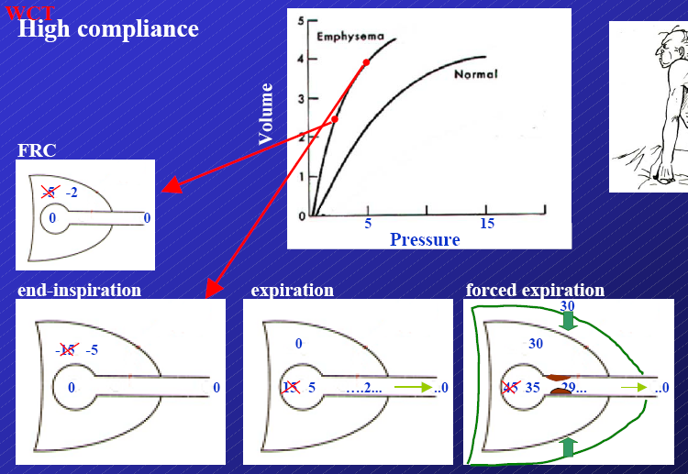
- For example, consider emphysema patients with low recoil pressures. The pressure in their pleural space is about -3 cm H₂0 (compared to -15).
- What happens? You get a collapse in the periphery.
- As you get to lower volumes in the periphery and therefore lower recoil, the chance of collapse increases.
- This is why you can’t cough before breathing in; you will collapse the peripheral airways at low volumes. First, you need to breath in so that there is enough recoil pressure and so that the equal pressure point will be in the larger airways
- Emphysema patients will start with lower pressures because their recoil is so low. When they breathe out, the driving pressure is only 5 and when they force air out, the equal pressure point is in the peripheral. As a result, they end up occluding their own airways, due to their collapse.

IX. BREATHING QUICKLY
What if you want to breathe in and out very quickly?
- Some animals can breathe very fast. We can exchange about 10% of our TLC with every breath, but some animals can exchange 70% of their TLC in a fraction of a second.
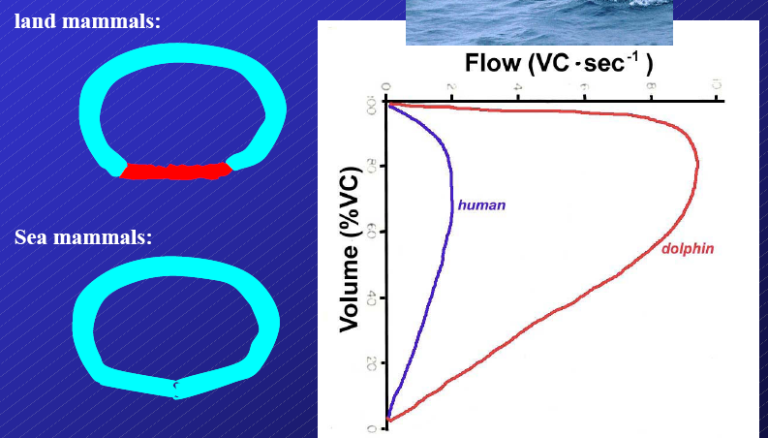
- Diving animals have to push air out and by having a special airway they are able to do this.
- Their airways are completely sealed by cartilage. We, on the other hand, have a soft portion in our airways and at the peripheries we lose our cartilage completely.
- Due to its structure, the airway of these animals are capable of supporting very high pressures and as a result, they can generate higher flows.

- The graph above illustrates a flow-volume curve. This is obtained by having a subject breathe out as much as he can, very quickly, starting at varying volumes. The highest flow occurs at the highest volumes. However, this is considerably less compared to the flow-volume curves of dolphins.
- This test and the flow-volume graph it produces are both very important.
  - One can see how much the subject can breathe out and how quickly he can do it.
  - Volume is on the x-axis, flow is on the y-axis
  - Inspiration is at the bottom, expiration is at the top
  - Flow goes down during inspiration, and up during expiration
  - When the subject pushes harder, he generates a higher flow but flow can reach a limit
    - It is quite high, especially when you start at high volume

PHGY 312 – Lecture 30 March 21, 2007
Writer: Chanudi Weerasinghe Dr.Mortola

Concepts Covered in the Last Lecture:
- The pressure-volume curve of the lung and the chest in isolation and combined.
- How changes in compliance have implications in the distribution of lung volumes.
  - Ex. Thicker lungs with lower compliance have a reduced FRC.
  - However, if the volume of the chest decreases equally then the FRC will drop equally.
  - So the combination of what the chest does and what the lung does effects the distribution of lung volumes like FRC, TLC, inspiratory capacity etc.
- Determinants of maximal and minimal lung volumes:
  - One cannot breathe more than TLC since eventually the lung and the chest tend to collapse.
  - One cannot breathe out more than RV since the chest springs out and upsets the maximum expiratory effort that is made.
- Dynamic properties of breathing include the air flow resistance and these dynamic properties help to build up the motion equation of the lungs.
- The P is the total pressure distributed by the muscles, P= V/C +R*Q change the pressure then you change the work done by the lung.
- The time constant is a physical concept of any mechanical system, In terms of the respiratory system it denotes the time it takes to respond; when a pressure is applied how long it takes for the air to come in. It is a property of resistance and compliance. The units cancel to give you time
- The mechanical event during spontaneous expiration, the pressure event, which eventually leads to forced expiration, and its volume-flow relationship.

Review Questions:

Note: Answers are in bold and underlined.

- The pressure opposing the maximal expiration is due to the outward recoil of:
  - The respiratory system
  - The lung
  - The chest

  - The outward recoil of the chest limits the lowest volume, which is automatically reflected on the respiratory system.
  - It is not due to the lung because the lung is always at a positive trans-pulmonary pressure. It always tends to collapse.

- A subject experience difficulties breathing in. The most likely reason is:
  - A decrease in diaphragmatic force
  - Increase in air viscosity
  - Loss of pulmonary surfactant
  - Increasing bronchomotor tone

  - All of the answers are correct to a certain extent.
  - A decrease in diaphragmatic force would decrease the inspiratory capabilities.
  - An increase in water vapour in the air would make the air denser. This may make it harder to breathe in because the air is heavier.
  - Any loss of surfactant would cause a decrease in compliance and the strength of dyspnea would be too great.
  - However, the question is asking which of the options is most likely to occur and although answers A-C are correct, these situations rarely occur.
  - An increase in bronchomotor tone happens during vasoconstriction. If this occurs, the force-power is applied the radius of the airways and increases the resistance of the airway greatly.

- During resting breathing, the time required to exhale depends on:
  - Time constant
  - Force applied
  - Compliance of respiratory system

  - The muscle force has no effect in this case, since the question is talking about resting breathing. The expiratory muscles are only engaged in forced expiration

- During a forced expiration:
  - Pleural pressure exceeds airway pressure
  - Airflow limitation depends on the transpulmonary pressure
  - Airway collapse is more likely to occur at high than low lung volumes

  - When the transpulmonary pressure is low then it is easier to have airflow limitation.
  - Expiratory flow can be increased if there is a high volume but the same increase cannot be seen at low volumes.

- It is easier to inhale rapidly from RV to TLC than to exhale rapidly from TLC to RV due to the fact that:
  - Expiratory airflow increases as lung volume decreases
  - At TLC the expiratory muscle generate little forces
  - The P-V curve of the chest wall helps inspiration

  - At FRC the chest wants to spring out and the lung wants to collapse, therefore at FRC the muscles have to be contracted to prevent the lung from collapsing.
  - During inspiration up to about 60% VC the chest helps bring air into the respiratory system.
  - However, this is a trivial contribution when the pressures are taken into account. This action occurs at a few cm H₂0 but the situation of interest is ~ 100 cm H₂O.

The Ventilation Distribution of the Lung

Where does the air go inside the lung?
- Consider the fact that the cardiac output (CO) in an adult man is ~ 5L/min. The pulmonary ventilation at rest is also 5L/min.
- If the CO (from the right ventricle to the pulmonary vessels), was to go to the left lung and the pulmonary ventilation was to go to the right lung, there would be normal CO and normal ventilation, but this would not be enough.
- It is not enough to have the proper CO and ventilation, they have to be distributed in such a way that they match perfectly. This is what we want to try to understand in this lecture.
- The tracheobronchial tree and the lung vasculature are very complex, and they have to match.
- The alveoli, which is the site of gas exchange, has to be surrounded by the proper number of capillaries.
- Given this complexity, how is it possible that the blood and ventilation are distributed evenly for one single breath? We are under the gravitational field of earth and therefore it must play a role in the distribution of the ventilation and perfusion.
- Through the action of gravity, it is expected that the bottom of the lung has more perfusion because of the weight. One cm of height is equal to one cm of pressure. The pressure of the blood and therefore the perfusion must be greater at the bottom.
- Air is not affected by gravity, but the factors that affect the distribution of ventilation are under the influence of gravity.
- So the affect of gravity is tremendous but there is still ventilation-perfusion matching.
- There are a variety of shapes and sizes of lungs. If we consider the Blue whale, the ribcage is the size of a small building and the heart is the size of a compact car.
- Also, during development lung size changes greatly. In some large mammals (elephant and rhinoceros) the change is a factor of 100.
- Some animals like to remain upside down, like the sloth and the bat. However these animals do not remain in this position forever. The shapes of the lungs changes with the changes in position.
- When we go from the supine to the upright position, FRC changes by about 30%. This creates a constraint on the distribution of perfusion and ventilation.

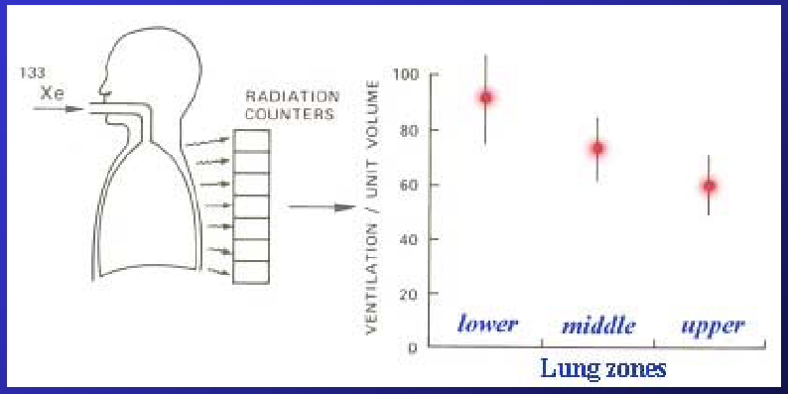
Experiment
- Add a small bolus of radioactive ¹³³Xe to the air in a spirometer, and place a number of radiation counters on the chest. This is done to see where the ventilation goes in the lungs by looking at the distribution of the radioactive material.
- There are different lung zones; the top of the lung is the upper zone in a standing individual.
- If the experiment was carried out with the individual supine then the top would be the sternum and the bottom would be the vertebral column.
- The gravitational vector can then be determined depending on the position of the subject (supine or standing).
- The top of the lung is sometimes called “gravity-independent,” but this is not exactly the case. The top of the lung (upper zone – area near the trachea and oral cavity) is less gravity dependent than the lower zones (area close to the diaphragm) in a standing individual.
- Through this experiment, it is determined that the ventilation per unit volume is higher at the bottom of the lung. The ventilation decreases as you move upwards in the lung but it is not a linear decrease.
- There is about a 50% difference in the ventilation between the top and the bottom of the lung.
- Therefore ventilation is not distributed evenly in the lung.
- The ventilation, if you are standing and breathing quietly, is preferentially at the bottom of the lung.

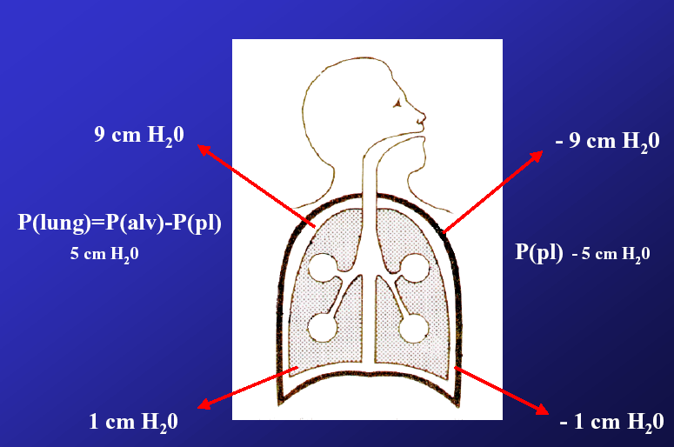
Why does gravity affect the ventilation distribution?
- The lung must be considered as a spring. This is a way to look at the lung in a static condition.
- In the static lung it is found that the top alveoli are more distended.
- So far, we have been discussing pleural pressure, measured through the esophageal pressure (because they are equal), and transpulmonary pressure as one single value.
- At FRC, the pleural pressure is -5 cm H₂O therefore the transpulmonary pressure is +5 cm H₂O.
P_{lung} = inside – outside = 0 – (-5) = +5 cmH₂O
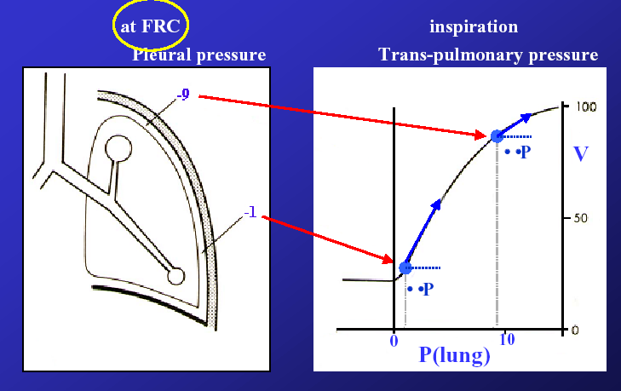
- The lung tends to collapse at this positive pressure.
- The value of “5 cm H₂O” is only an average. The value will change slightly in different parts of the lungs.
- The pleural pressure is -9 cm H₂O at the top of the lung and -1 cm H₂O at the bottom of the lung. Therefore the transpulmonary pressure at the top is 9 cm H₂O and the transpulmonary pressure at the bottom of the lung is 1 cm H₂O.
- The pleural pressure is the result of the weight of the fluid in the lung. This weight makes the pleural liquid pressure (the pressure of the fluid contained within the pleural space – between the lung and the chest wall) more positive.
- If you have a balloon that is only distended by 1 cm H₂O, then it is not very distended and is less distended than a balloon at 9 cm H₂O. This explains why the top of the lung is more expanded, since there is a more negative pleural pressure and a more positive transpulmonary pressure.

- When there is active inspiration, the muscles are contracted and a pressure is developed and this pressure is ∆P.
- With the change in pressure from the bottom to the top of the lung, there is also a corresponding change in volume.
- The top of the lung is exposed to the same difference in pressure but since the alveoli are already distended they are less compliant and therefore receive smaller ventilation (quantity of air).
- The bottom of the lung is less distended therefore has a greater compliance and receives more of the ventilation.
- There are many factors that affect ventilation, including the unevenness of pleural pressure caused by gravity.
- Pleural pressure is less negative at the bottom, and the transpulmonary pressure is much larger at the top. This means that the lung at the top is already distended and therefore less compliant thus less air will go to the top of the lung.
Take Home Message: Gravity affects the ventilation distribution because it acts on the fluid in the lung. The weight of the fluid in the lung is what produces pleural pressure. This pressure is more negative at the top and less negative at the bottom, to produce trans-pulmonary pressures that are higher at the top and lower at the bottom. This causes the top of the lung to be less ventilated.

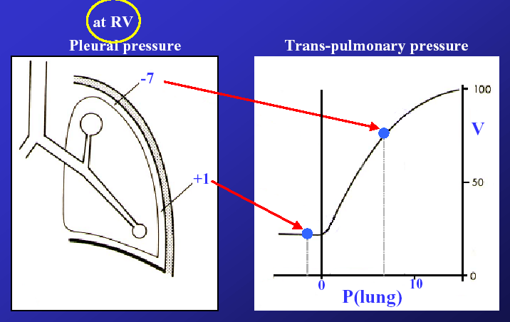
Explanation of Ventilation Unevenness:
- There are two factors which explain the ventilation unevenness:
- The pleural pressure gradient (gravity dependent)
- Curvilinearity of the P-V curve
- If the P-V curve was linear and if compliance was independent of lung volume, then ventilation would be even, irrespective of how large the alveoli are at FRC.
- If inspiration was started at a lower lung volume, at RV, the lung is being squeezed.
- The transpulmonary is ~ 2 cm H₂O since the lung is at a smaller volume.
- The top of the lung is now at a pleural pressure of -7 cm H₂O and the bottom of the lung is at a positive pleural pressure. This means that outside the lung, the pressure is higher than the inside and therefore the bottom of the lung collapses.
- When you breathe out to RV, you decrease lung volume and close the bottom of the lung. If you now try to breathe in, the air cannot go to the bottom of the lung since it is closed but the air will go to the top of the lung.
- If there is a positive pleural pressure and a negative transpulmonary pressure, this means that the lung is on the closed area of the P-V curve and air will go to the top of the lung.
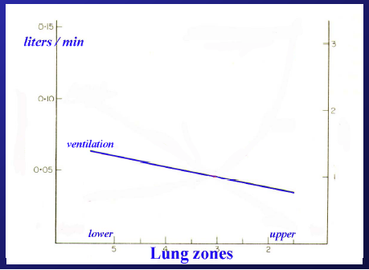
Summary
- Ventilation is unevenly distributed in the lung and this is due to the effect of gravity which creates a pleural pressure gradient so that some of the alveoli in the lung are more expanded than others.
- The P-V curve of the lung is a-linear so if you start with a part of the lung that is inflated then that part is less compliant. This is a situation found when breathing from FRC (the most common situation).
- Moreover, the absolute lung volume also determines how ventilation is distributed in the lung, which explains the results in the experiment using ¹³³Xe.
  - The bulk of the ¹³³Xe is going to the bottom of the lung because the bottom is more ventilated from FRC.
  - However, if this experiment were conducted from RV, then the bottom of the lung would not be ventilated.
- Therefore, it is important to note that the lung zone vs. ventilation graph will change depending on whether the measurements are done at FRC or RV.
- This links back to the video of the inflation of the collapsed lung.
- When a lung is being re-inflated from a collapsed state, it inflates unevenly.
- This costs a lot of energy and that is why we have an FRC of ~2L, to ensure that we have a reserve of oxygen and to keep the lungs inflated.
- If we started to inflate the lungs when it was collapsed at the bottom, the bottom would not be inflated at all. Most of the air would go to the top, so the ventilation would be very uneven compared to perfusion.
- Remember that if we breathe from FRC, ventilation is mostly at the bottom and gradually less at the top. However, do not think that the top of the lung is not ventilated. It is just receiving substantially less air than the bottom.
- In situations where there is no gravity, or there is significantly less gravity, then the ventilation distribution changes.
  - When there is no gravity, there is no unevenness in ventilation distribution.
  - In cases such as on the Moon, the gravity is 1/6 of what it is on Earth. Therefore, the unevenness of ventilation distribution is 1/6 of what it is on Earth, meaning that the distribution is more even on the Moon than on Earth.

- Though we have been saying that ventilation is uneven, it may not be as uneven as we think it is.
- Based on engineering, calculations on how the lung is built, the prediction could be that ventilation is very uneven, but this is not the case.

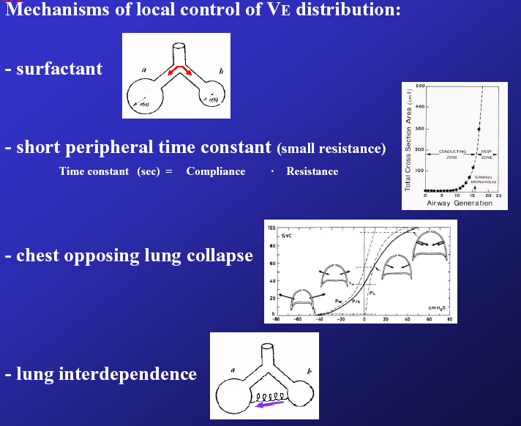
Reasons That Ventilation Unevenness is Not as Bad as Predicted
- This is due to four factors:
- Surfactant
- Allows alveoli of different sizes to have the same pressure by decreasing the surface tension.
- Premature babies that have a lack of surfactant have such a severe unevenness in ventilation that it leads to death.
- Short pleural time constant – Time constant = Compliance x Resistance.
- The time constant determines the length of time it takes for ventilation to be distributed throughout the lung.
- The time constant in the periphery of the lung is very small because the resistance is very small since the air in that area is hardly moving.
- The lung has a large surface area therefore velocity of the air is very small. The air flow is laminar.
- This means that the resistance of the lung periphery is also small.
- The short time constant is good for ventilation since it means that the air will go to all parts of the lung very quickly.
- If the time constant was large, air would take more time to reach the periphery.
- This is why in cases where there is mucous in the periphery or bronchitis or tumors, resistance is increased which makes the time constant larger. This causes the ventilation to be adversely affected - the ventilation distribution suffers.
- Chest
- The chest helps since it springs out opposing the tendency of the lung to collapse and increase the airway resistance.
- When you go to RV, the bottom of the lung is collapsed, but if the chest was not opposing this, it would be even more collapsed.
- Lung interdependence
- All of the alveoli in the lung are connected together by the interstitium (the lung parenchyma).
- Consider two alveoli attached together by springs.
- One of the alveoli gets bigger and the other is not ventilated.
- The first alveolus tends to pull open the second alveolus by stretching the spring.
- This happens irrespective of the presence of surfactant.
- Because the alveoli are all connected together, the more ventilated regions of the lung will pull on the less ventilated regions to help open up those alveoli.

The Perfusion Distribution of the Lung
- Blood has a much higher density than air therefore it is expected to be more unevenly distributed than ventilation.
- The blood is poorly distributed within the lung.
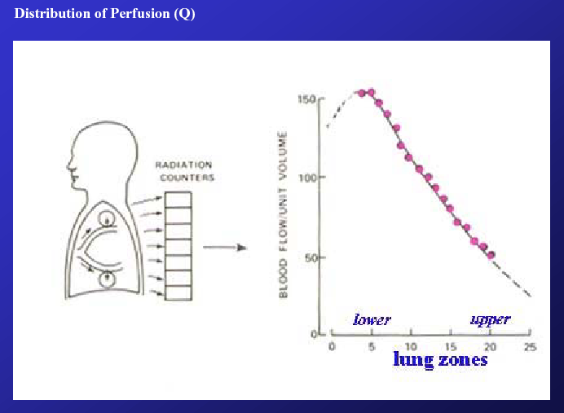
Experiment
- The same experiment that was used to determine ventilation distribution can be repeated to determine the perfusion distribution of the lungs, with some modifications.
- The radioactive material is placed directly into the blood. Radiation counters are placed on the chest.
- The distribution of perfusion is measured as a function of the lung zones.
- What is revealed is that there is an enormous gradient. The bottom of the lung receives a much larger volume of blood compared to the top of the lung.
- The perfusion gradient is due to the action of gravity. More blood goes to the bottom since there is greater pressure.
- At the bottom of the lungs, the capillaries are much more expanded.
- At the top the alveoli are expanded and the capillaries are less expanded. There is still some perfusion but it less per unit tissue.

- The pulmonary circulation is a low pressure system and the pulmonary arterial pressure is 30mmHg. It is this pressure that drives blood into the lungs.
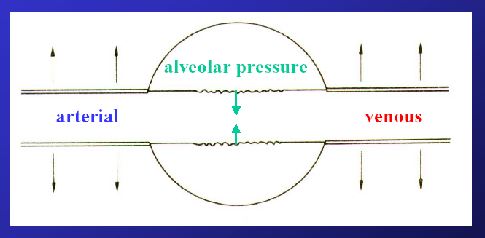
- This means that small changes in posture will significantly change the perfusion since the driving pressure is so low.
- For any organ in the body, the driving pressure for blood flow is (P_{art}-P_{v}), but this is not the case for the lungs. This is due to the fact that the lung has alveoli.
- What drives the blood through the lungs is the arterial-alveolar pressure difference.
- If alveolar pressure becomes high, the flow of blood will cease. In other words, the capillaries are running within Starling resistors. Alveolar pressure rises above atmospheric pressure during expiration.
- However, if air is being forced out, like during a cough, the alveolar pressure rises above arterial pressure in the pulmonary vascular bed and you stop the blood flow.
- This is the reason why you get red in the face when you are blowing up a balloon – the blood flow has stopped.
- This means that the way that blood travels in the lungs has to do with the breathing action.

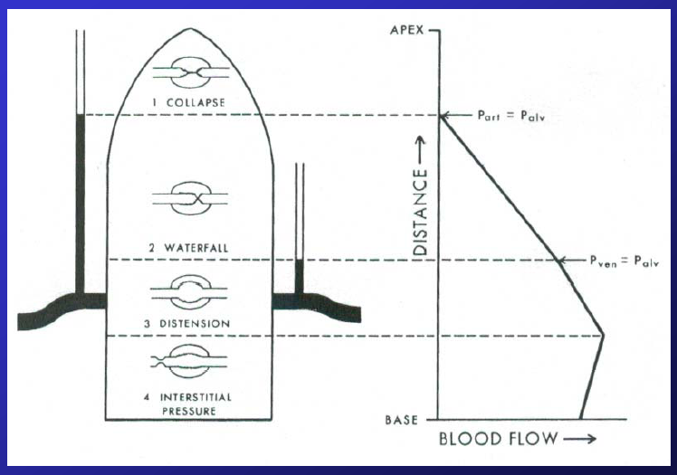
Perfusion During Diaphragmatic Breathing vs. Passive Inflation
- During diaphragmatic inspiration (which is the normal situation), the pleural pressure becomes negative and the alveolar pressure also becomes subatmospheric and the capillaries are expanded
- During the following expiration, the alveolar pressure increases above atmospheric pressure and the capillaries are compressed.

- In passive inflation, pleural pressure is positive during inspiration and expiration. Therefore the patient will have a risk of limiting their CO during both inspiration and expiration.
- As the person performing CPR continues to pump the chest, they are not actually helping the patient.
Recall: Passive inflation is an artificial situation such as when the subject is not breathing and air must be pumped into their lungs.
- The same situation occurs in open-chest surgery. Because the chest is open, this means someone is ventilating the patient. The person ventilating the lungs is creating a positive pleural pressure at both inspiration and expiration.
- The PO₂ will drop and they will ventilate more, aggravating the situation. They do not realize that the lack of O₂ is due to an over-positive pleural pressure which causes occlusion of the vasculature.
- Now they have increased the amount of chest compressions per breath during CPR.

Summary
- The bottom of the lung is the gravity dependent portion and receives most of the perfusion, though there is some perfusion at the top of the lung. Perfusion increases as you go from the top to the bottom of the lung.
- However, the amount of perfusion at the very base of the lungs decreases since there is a squeezing of the base of the lungs which collapses alveoli.
- In Zone 2 (refer to the diagram above), blood flow is determined not by the usual arterial-venous difference but by the alveolar-arterial pressure difference. This difference accounts for the unevenness of perfusion.
Note: In the next lecture, we will discuss how ventilation and perfusion are matched.

PHGY 312 – Lecture 31 March 23, 2007
Writer: Laura Robinson Dr. Mortola

RESPIRATORY PHYSIOLOGY – GAS TRANSPORT

I. COVERED IN THE LAST LECTURE
- Effects of gravity on pleural pressure and the pleural pressure gradient
- Distribution of ventilation and effects on lung volume (ex. gravity)
- Factors responsible for ventilation gradient (ex. gravity)
- Factors that make ventilation distribution different from what we would have predicted (ex. surfactant)
- Distribution of perfusion, what drives the flow (ex. arteriolar alveolar pressure)

II. REVIEW QUESTIONS FROM LAST LECTURE
Correct answers are bolded.

- The main factors causing unevenness in ventilation distribution within the lungs is/are:
  - Gravitational field
  - Pleural pressure gradient
  - Curvilinear shape of the pressure-volume graph I
- You need a curvilinear curve to cause an uneven distribution. The bottom of the lung is less inflated and the top of the lung is more inflated to start with, due to the effects of gravity and pleural pressure gradient.
- Due to the curvilinear curve we know the top of the lung is less compliant.
- If this was not true and the line was linear, the top of the lung would start off more inflated and the bottom of the lung would start less inflated, and when you applied a pressure, both would get the same amount of air.
  - Lung volume at which inspiration occurs
- If we breathe at a very low volume (ie. RV), the bottom of the lung closes and cannot get any air until it opens again. If we breathe in starting at a bigger volume, such as at FRC, most of the air goes to the bottom of the lung because it more compliant.
  - All of the above are true

- The main reasons for perfusion being distributed preferentially in the lower regions are
  - Gravitational field
  - Alveolar pressure controlling capillary flow
- It is indeed controlling capillary flow but if the flow in lungs was simply the difference between arteriolar and venous (like any other organ), would it cause the unevenness in perfusion? No. So it might be a tiny role, but not a main role.
  - Low pulmonary pressure
- It is true that it works at a low pressure (20-30 mmHg) but if it were a high pressure system, then the tiny differences in the height of the lungs would not play a major role. The top of your lungs is probably only 30 cm H₂O, which is less than 20 mmHg, so whether or not it is working at a high or low pressure doesn’t really matter. It may play a minor role, but not a main role.

Note: Someone asked Dr. Mortola why he doesn’t put these questions up on WebCT. Dr. Mortola said that he does not consider these to be exam type questions. He only uses them to review what we covered in the previous lecture and to illustrate that some of these concepts have grey areas; they are not completely black-and-white. However, on our exam he will be asking us black-and-white questions.

III. VENTILATION-PERFUSION RATIO (VA/Q)

- It is not enough to know where the blood and air go. We need to how, where and to what extent these two factors match within our lung.
- In physiology, this is called the ventilation perfusion ratio, VA/Q, where perfusion (Q) is the amount of blood circulating per unit time (ml/min) and ventilation is the amount of air mechanically exchanged per unit time (ml/min)
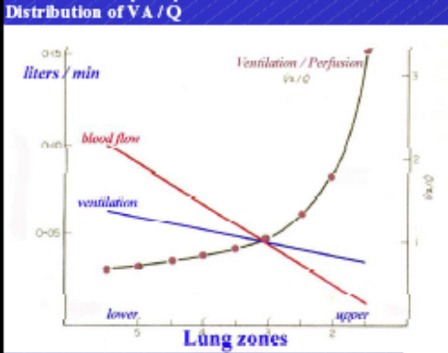
- Graphs illustrating the distribution of ventilation and the distribution of perfusion can both be obtained using very similar conceptual approaches.
- Injection of substances into the pulmonary circulation or inhalation of radioactive gases show that if you are breathing from FRC, the bottom of the lung is over-ventilated and over-perfused.
- However, as we can see (Figure A) the slope of the ventilation and perfusion lines are different. The unevenness of perfusion exceeds the unevenness of ventilation.

Bottom of the lung:
- The lower part of the lung is gravity dependant. This region receives more air and disproportionately more blood.
- Therefore, the VA/Q ratio is low (0.7), meaning there is greater perfusion than there is ventilation.
- Under extreme situations, regions of the lung will be very well perfused but poorly ventilated and thus, we can say that these regions behave like a “blood shunt”.
- As the ratio approaches 0, blood is traveling to the lungs but not finding any air

Top of the lung:
- This region of the lung is gravity independent. It gets less air and blood, compared to the bottom.
- Therefore, the VA/Q ratio is high (about 3) since ventilation is exceeding perfusion
  - As we can see, the change in VA/Q, at the top versus at the bottom of the lung, differs by a factor of 3-4.
- Your lungs are receiving a lot of air for gas exchange but there is not enough blood being delivered for gas exchange to occur to its maximum potential. As a result, the top of your lung acts almost like a dead space.

Take Home Message: Due to their differences in VA/Q ratios, the bottom of the lung approaches the situation where it acts as a blood shunt, while the top of the acts like dead space. Note that it is not just the ventilation or the perfusion alone that matters for gas exchange; it is the ratio of the two, VA/Q.

- In extreme situations, for example too much blood shunting, a patient may become hypoxemic (low oxygen concentration in their arteriolar blood.).
- This is because the cardiac output is being sent to the lower lung, where the VA/Q ratio is low. It is no longer being used for gas exchange, thus the blood that is returning to the left ventricle and being pumped out to the systemic circulation is hypoxic.
If you find a patient that has blue fingers, how do you determine whether they have problems with ventilation and/or perfusion (VA/Q inequality), respiratory mechanics or diffusion?

- To determine what the problem is, the patient a hyperoxic test. In other words, the patient is give pure oxygen to breathe in.
- If the patient has a diffusion problem, then they should improve because diffusion is related to the pressure gradient. For example, if you give 700 mmHg you are increasing the pressure gradient by a factor of 5. Recall inspired air has a P_{O2} of 150 mmHg.
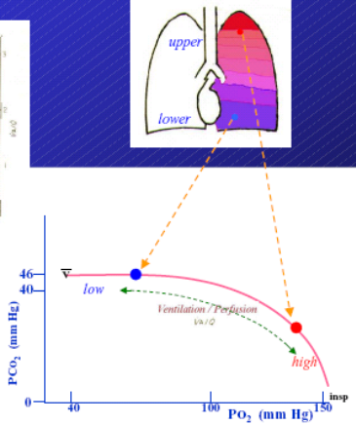
- What if the problem is a shunt (perfusion exceeds ventilation)? In this case, increasing oxygen will not matter and there will be no improvement in the patient. This is because the shunt blocks oxygen from reaching the blood, regardless of the P_{O2}.

IV. P_{O2} AND P_{CO2}
- As discussed above, the bottom of the lung there tends to be a shunt region, or a shunt-like region. On the other hand, the top of the lung is highly ventilated and acts like dead space. We are now going to look at what these properties imply.
- The upper diagram of the lungs is a very famous diagram, due to its simplicity. The graph below shows the P_{O2}-P_{CO2} relationship in the lungs (where P_{O2} is usually plotted on the x-axis and P_{CO2} on the y-axis).
- Inspired value of oxygen approaches 150 mmHg because P_{O2} is 20.9% of barometric pressure (760 mmHg)

Note: 20.9% of 760 mmHg is higher than 150 mmHg, but you need to subtract the presence of water vapour in the air. Therefore, this is why the PO2 is 150 mmHg and not greater.

- “V-bar” (V with the bar above it) denotes mixed venous. V alone means venous, the bar means mixed. This indicates that you are sampling from the right atrium (ie. from venous blood returning to the heart from the systemic circulation).
  - If you average all of the blood returning to the right atrium, it will have a P_{O2} of about 40 mmHg, while the average arterial blood has a P_{O2} of 100 mmHg.

- Remember, when you are breathing from FRC, the top of lungs are over-ventilated, while the bottom of the lungs are under-ventilated
- This means the blood leaving the top of the lungs has a higher P_{O2} (140 mmHg) and a lower P_{CO2} (30 mmHg).
- On the other hand, blood leaving the bottom of the lungs has a lower P_{O2} (40 mmHg) and a higher P_{CO2} (46 mmHg). Both of these values are closer to the venous concentrations, than the values found at the top.
- The blood leaving the top of the lungs has a higher concentration of P_{O2} and a higher P_{CO2} than the blood leaving the bottom of the lungs because the top of the lungs has a higher VA/Q ratio (and a higher ventilation).
- A range of values between these two extremes are found in the middle of the lungs. In addition, these numbers vary with posture and lung volumes.

Underwater Example:
Recall the image of the man breathing through a snorkel at the bottom of a swimming pool.
- We concluded that 150cm would be the max depth he could snorkel to because that was the maximum respiratory pressure. However, Dr. Mortola also noted that if he actually did this, the man would probably break his capillaries.

What if he did not use a snorkel and just breathed in water?
- The partial pressure is not different because the P_{O2} in the air will equilibrate with the P_{O2} in the water. This equilibration usually occurs at a P_{O2} of 150 mmHg, the P_{O2} found at sea level.
- Our problem will be with the quantity of oxygen in the water is very different. In the air we have 20.9% of oxygen, but in the water this value is much lower, usually about 0.5% (0.5 mL/100 mL of water)

We need to decide which is value is important, the partial pressure of oxygen or the quantity of oxygen?
- We know pressure is very important because it is what drives diffusion.
  - At the level of the mitochondria, it is the molecules of oxygen present that are important, but we need a pressure gradient to drive the diffusion of these molecules.
  - This is why if the arteriolar blood oxygen pressure is too low, even if you still have oxygen in your blood, you will become hypoxic and may die because the pressure gradient is not large enough to move the oxygen molecules into the mitochondria.
- As we can see, the pressure and the quantity of oxygen are both important. Water has the high oxygen pressure needed, thus the problem will be in the quantity of oxygen present, which is very low.

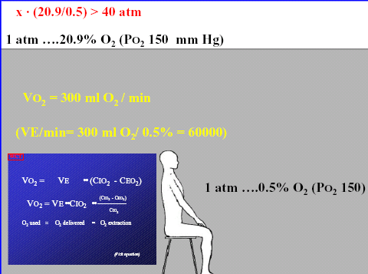
How much oxygen does the man need?
- The minimum resting oxygen consumption is 300ml O₂/min, but we only have 0.5 ml of O₂/100 ml in the water.
- Recall that:

V_{O2} = V_{E} x (C_{IO2} – C_{EO2})
V_{E} = V_{O2} / (C_{IO2} – C_{EO2})

- If we pretend the individual was able to extract all the O₂ available in the water, in order to fulfill his metabolic need, all he would have to do is pump more.
V_{E} = 300ml /0.5% = 60 L/min
- Therefore, under water, the man would need to pump 60L/min in order to fulfill his metabolic needs.
  - Obviously, this value is absurd. Breathing at these levels takes a lot of energy.
  - In addition, the viscosity of water is much higher than the viscosity of air. Thus, the work needed to breathe is even greater.

There’s another solution to this problem.
- Seal off the pool completely and then pressurize it, from 1 atm up to a pressure that is 40x higher.
- As you increase the pressure within the compartment, equilibrium will raise the oxygen concentration in the water, up to what we enjoy in the air.
- The P_{O2} will now be so high, that by just keeping the mouth open, the oxygen in the water will simply diffuse in and out.
- Obviously this is not simple, but it is possible!

- A problem with premature babies that are born without surfactant is keeping them ventilating
  - A solution to this problem may be to put them in a pool and let them get oxygen by diffusion through their mouth

- People have also been trying this technique with solutions that have a high affinity for oxygen
  - For example, per fluoro chemical liquids are saturated with 100% oxygen
  - This strategy has already been carried out on mice
O₂ Removal and Transport in the Blood:
- After a surgery, the surgeon puts everything back in order and sews the patient back up. One thing they never worry about is the air; they never make any point to pump it out. Why? We will answer this question in the following slides.

Let’s review gas transport briefly:
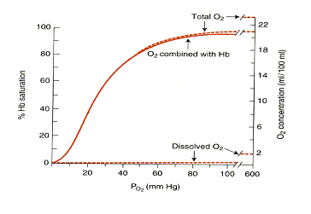
- If we just had plasma in our vessels, we could only obtain an oxygen concentration of 0.3% in our blood. This is known as the physically dissolved O₂ content. Dotted line in the graph.
- Even at the highest oxygen pressures (600 mm Hg) you can only get to 2% into your vessels with just plasma.

- Fortunately, we have haemoglobin (Hb) in our blood. Therefore, the concentration of oxygen is much higher (20%) because Hb increases the capacity for blood to carry oxygen. Curved solid line in the graph.
- In addition, we can see that the total O₂ in the blood, the combination of dissolved O₂ and Hb transported O₂, produces a curve that is almost exactly the same as the haemoglobin curve. Curved dotted line in the graph.

- The shape of the curve has to do with how oxygen is loaded at the level of the lung and how it is unloaded at the level of the tissue.
- We are able to decrease the partial pressure of oxygen to about 60-70 mmHg and still get a full load of O₂ in the blood. But as soon as you begin to reach the tissues (P_{O2} of 40 mmHg), the saturation of Hb drops very quickly and dramatically, thus releasing oxygen into the tissues.

- Haemoglobin is also able to change its affinity for oxygen depending on the situation. For example, it can change under the influence of varying CO₂, H⁺ levels and temperature.
- The curve is shifted to the right when acidity, CO₂ and temperature increase. This means O₂ is being to unload at higher oxygen partial pressures.
  - This property is beneficial and wanted at the levels of the muscles because muscles want high levels of oxygen quickly. This occurs because when muscle activity increases lactic acid is produced, CO₂ production is increased and heat is released.
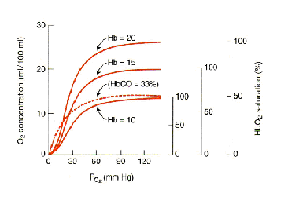
- If you change the quantity of haemoglobin (ie. from the normal level of 20 down to 15 or 10), the content of oxygen decreases, not the P_{O2} in the blood.

- It is very dangerous to breathe in carbon monoxide (CO) because it has an enormous affinity for haemoglobin (200X higher than O₂). Thus, CO poisoning would be equivalent to losing large quantities of blood, since you are losing the available Hb for O₂ binding.

Consider the following example:
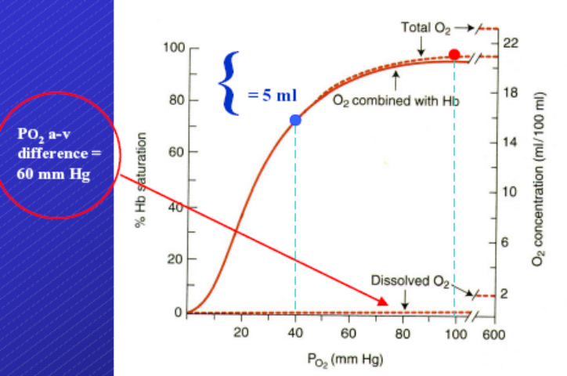
- At arterial P_{O2} (100 mmHg), the Hb is almost fully saturated and we have an O₂ concentration of about 20%
- In the mixed venous blood (P_{O2} = 40 mmHg), the Hb is about 75% saturated and we have an oxygen concentration of about 15%
- The arteriolar-venous oxygen concentration difference is about 5ml/100ml (5%)
- The P_{O2} difference between the arterial and venous blood is 60 mmHg (100-40 = 60 mmHg)
- The partial pressure of oxygen difference between A and V is about 60 mm Hg (100-40)
- The haemoglobin disassociation curve is sigmoid, so for a 5% change in oxygen concentration we have a 60 mmHg drop in P_{O2}.

C_{O2} Removal and Transport in the Blood:
- CO₂ is transported via Hb and other transporters. It is also physically dissolved in the blood. Note that CO₂ has a higher solubility than oxygen, 20-25x more.
- However, these methods transport only very small amounts of CO₂.

- The main way that CO₂ is transported is by bicarbonate ions.
- Bicarbonate is found in the plasma but it is produced by RBC.
- Recall the following reaction:

CO₂ + H₂O ↔ H₂CO₃ ↔ H⁺ + HCO₃

Where the step CO₂ + H₂O ↔ H₂CO₃ is driven by carbonic anhydrase.

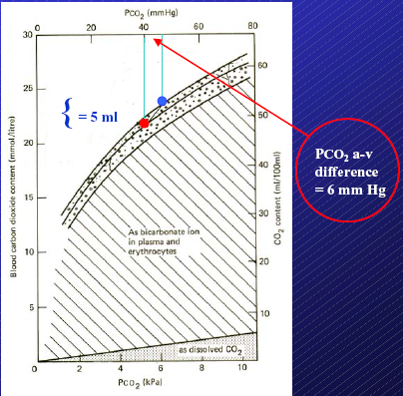
- When you sum up all the ways that CO₂ is transported, the relationship between P_{CO2} and CO₂ concentration is almost linear.
- The P_{CO2} difference between the arterial and venous blood is 6 mmHg (46-40 = 6mmHg), while the CO₂ content difference is about 5 ml.
- It is about 5 ml because the tissues are taking up about 5% O₂. This means the blood will be taking about 5% CO₂ away.

- Therefore, in the tissues on the oxygen end, we are dropping the PO₂ by about 60 mm Hg, while we increase P_{CO2} by 6 mmHg.

What does this mean with respect to the partial pressure in the blood?
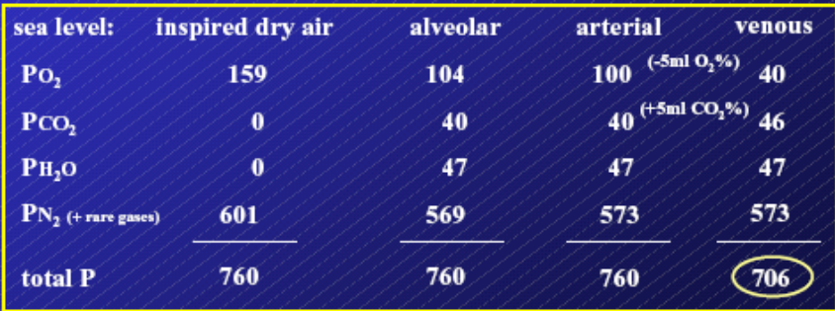
Inspired Dry Air:
- In Montreal, the P_{O2} is 159 mm Hg because the air is very dry
- In addition, the P_{H20} and P_{CO2} are zero.
- The rest of the partial pressure is nitrogen (P_{N2} = 601 mmHg), making a total pressure of 760 mmHg (or 1 atm)

Inside the Alveoli:
- There is a jump in P_{CO2} (40 mmHg)
- The air is also fully saturated, thus there is a P_{H20} of 47 mmHg.
- Since P_{N2} and P_{O2} have fallen slightly, in the end, the sum of the partial pressures is still 760 mmHg.

Arterial Partial Pressures:
- P_{O2} (100mmHg) is relatively the same because diffusion in the lungs is very good
- P_{CO2} and P_{H20} are also the same.
- Thus, the partial pressure is still 760 mmHg.

Venous Partial Pressures:
- P_{O2} drops dramatically from 100 to 40 mmHg
- P_{CO2} increases from 40 to 46 mmHg
- P_{H20} stays the same
- Therefore, the total sum of the partial pressure has dropped to 706 mmHg
- The venous pressure is now “sub-atmospheric” by quite a bit (54 mm Hg)

- This is why surgeons do not care about pumping out extra air after surgery. In no time, it will be absorbed by the venous blood.

